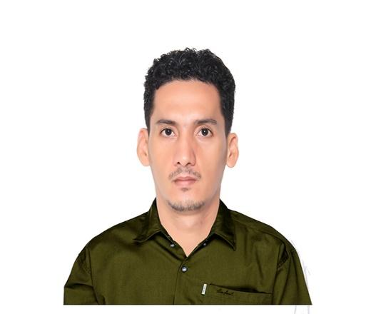
Name: Jose Homan Such
Contact Information
Address: CAA Pulang Lupa Dos Las Piñas, Metro Manila
Phone: (+63) 992-062-8858
Email: suchjose@live.com
LinkedIn: suchjose@live.com

Summary
Motivated and detail-oriented junior front-end developer with almost 10 years of experience in the customer service industry and studied Full Stack Web Development at Brigham Young University as an online student. Strong skill in Web Development. Proven ability to work well in a team and deliver projects on time. Proficient in creating visually appealing and responsive web pages.

Link to Web Dev Portfolio - https://main.dddwoour5azq2.amplifyapp.com/

Work Experience

Freelance Web Developer, Upwork.com – March 2023 - Present
- Assist in the development, testing, and maintenance of web applications. Work with front-end technologies like HTML, CSS, JavaScript, and frameworks like React, Angular or Vue.js.
- Develop and maintain backend functionality using Node.js, Python (Django/Flask), or PHP
- Collaborate with designers and senior developers to implement UI/UX designs. Debug and troubleshoot issues in existing applications.
- Optimize web applications for speed and scalability. Work with APIs, databases (MongoDB, MySQL, PostgreSQL), and third-party integrations.

Technical Support, Quantrics Enterprises - December 2020 – March 2023
- Provide support for Bell, the biggest Telco in Canada.
- Troubleshoot and resolve technical issues related to internet, home phone, and cable tv.
- Provide remote and on-site support to clients.
- Document and track all support requests using a ticketing system.
English as a Second Language Tutor, Bizmates Incorporated - November 2017, September 2020
- Responsible for helping Japanese professionals improve their English reading, writing and speaking skills.
- Help clients proofread and revise documents in English like reports, resumes, etc.
Real Time Analyst, C3, Bonifacio Global City - April 2016 – January 2017
- Monitoring and analyzing real-time data to ensure performance metrics are met.
- Identifying and troubleshooting issues that arise in real-time.
- Providing support to front-line staff.
- Monitoring and managing staff schedules.
- Providing coaching and feedback to staff.
- Working with other teams to improve processes and procedures.
- Creating and maintaining performance reports.
- Participating in continuous improvement initiatives.
Credit Card Fraud Analyst, Convergys Philippines Inc, NCR, July 2015 – March 2016
- Fraud Analyst for captive company American Express.
- Monitor and analyze credit card transactions for suspicious activity.
- Investigate and verify potential fraud cases.
- Collaborate with internal and external partners to gather information and evidence.
- Identify and implement strategies to prevent future fraud.
- Keep abreast of the latest trends and developments in credit card fraud.
- Communicate with customers and financial institutions to resolve fraud cases.
Debit Card Fraud Analyst, JP Morgan Chase Bank, NCR, December 2013 – April 2015
Customer Service Representative, Convergys Philippines Inc, NCR, June 2013 – November 2013
Real Time Analyst, Sutherland Global Services, January 2008 – October 2011

Education
Brigham Young University - Idaho, Web Development, 2020 – 2024
Philippine Merchant Marine Academy, 2001 – 2004
Camarines Sur National High School, 1995 - 2001

